Project Design Phase-II

Data Flow Diagram & User Stories

|  |  |
| --- | --- |
| Date | 03 October 2023 |
| Team ID | NM2023TMID08080 |
| Project Name | Project-Solar panel Forecasting |
| Maximum Marks | 4 Marks |

# Data Flow Diagrams:

A Data Flow Diagram (DFD) is a traditional visual representation of the information flows within a system. A neat and clear DFD can depict the right amount of the system requirement graphically. It shows how data enters and leaves the system, what changes the information, and where data is stored.

# Example:

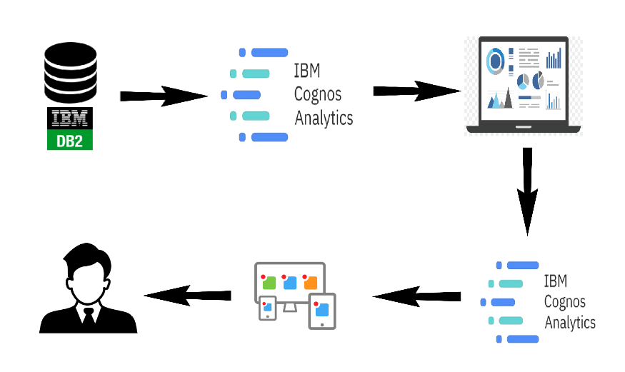

**Architecture:**

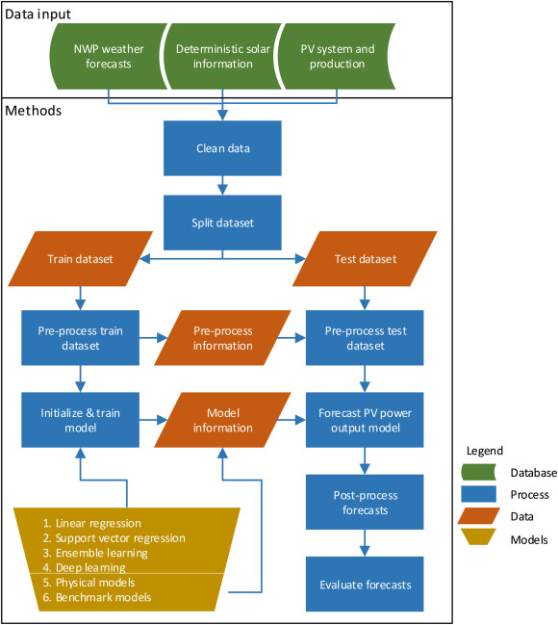

**User Stories**

Use the below template to list all the user stories for the product.

|  |  |  |  |  |  |  |
| --- | --- | --- | --- | --- | --- | --- |
| **User Type** | **Functional**  **Requirement (Epic)** | **User Story Number** | **User Story / Task** | **Acceptance criteria** | **Priority** | **Release** |
| Customer (Mobile user) | Registration | USN-1 | As a user, I can register for the application by entering my email, password, and confirming my password. | I can access my account / dashboard | High | Sprint-1 |
|  |  | USN-2 | As a user, I will receive confirmation email once I have registered for the application | I can receive confirmation email & click confirm | High | Sprint-1 |
|  |  | USN-3 | As a user, I can register for the application through Facebook | I can register & access the dashboard with Facebook Login | Low | Sprint-2 |
|  |  | USN-4 | As a user, I can register for the application through Gmail | I can receive confirmation email & click confirm | Medium | Sprint-1 |
|  | Login | USN-5 | As a user, I can log into the application by entering email & password | I can access my account / dashboard | High | Sprint-1 |
|  | Dashboard | USN-6 | As a user can access dashboard to use application bfor their need | I can get suggestions from my relevant information | Medium | Sprint-2 |
| Customer (Web user) | Register | USN-1 | As a user, I can register for the website by entering my email, password, and confirming my password | I can access my account / dashboard. | High | Sprint-1 |
| Customer Care Executive | Customer Interaction Management | USN-1 | The system should allow customer care executives to view and manage customer inquiries, complaints, or requests effectively. | The Customer Care Executive should have access to the necessary customer information, including contact details, account status, and any relevant support history. | Medium | Sprint-2 |
| Administrator | User Management | USN-1 | The administrator should be able to create, modify, and delete user accounts. | The changes made by the Administrator should reflect accurately in the user database. | High | Sprint-1 |
|  |  | USN-2 | The administrator should have the ability to reset user passwords and manage user roles and permissions. | Any modifications to user roles and permissions should be successfully updated and applied. | High | Sprint-2 |
|  | Report Generation | USN-1 | The administrator should have the ability to generate various reports related to user activities, system performance, and any other relevant data points. | The system should allow the administrator to configure the parameters for generating reports, including selecting the desired data fields, time periods, and specific metrics to be included in the report. | High | Sprint-1 |